Register for IBM Cloud

Project Name: Machine Learning based Vehicle Performance Analyzer Name: BHARATHI J R

Industry Mentor(s) Name : Nidhi

Faculty Mentor(s) Name : **S.TAMIZHARASU**

1. IBM Cloud Account Created:

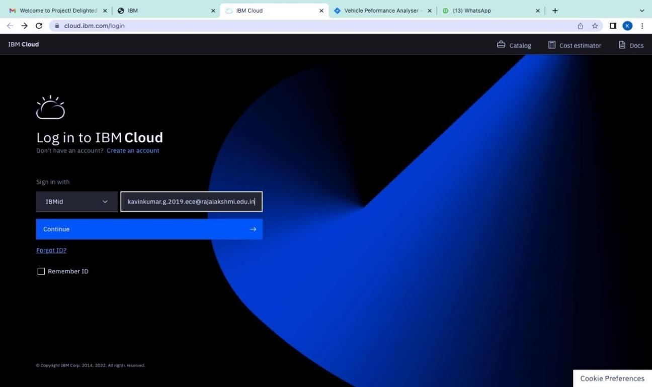

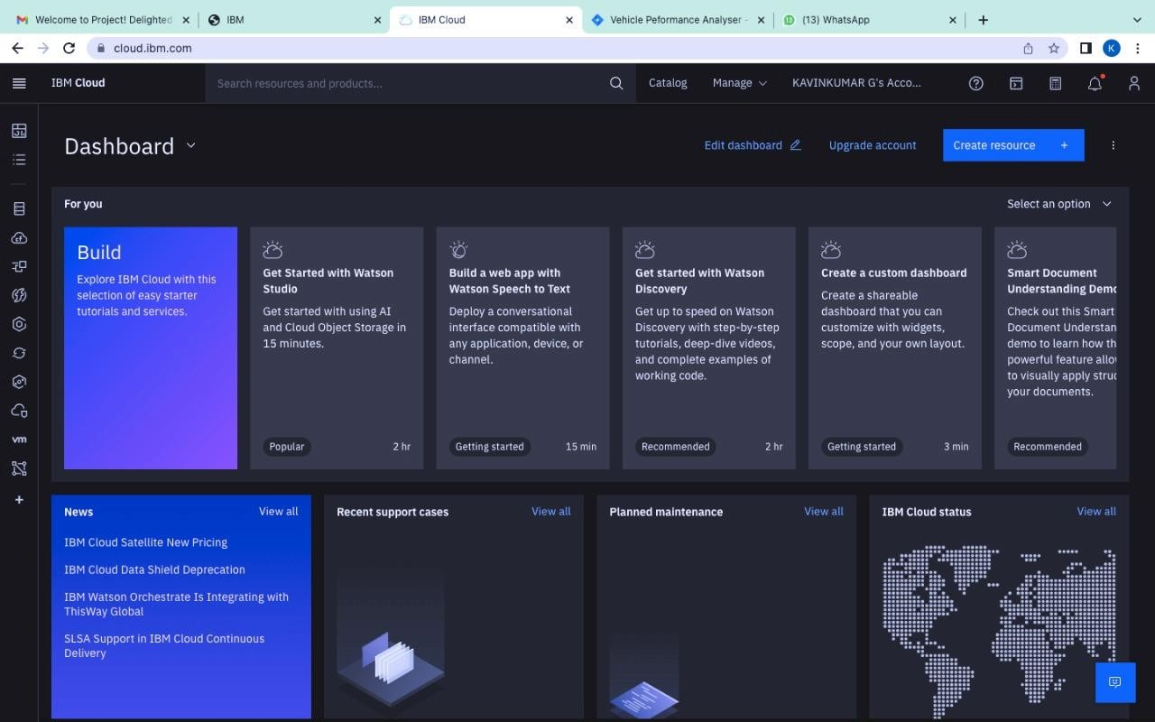

1. Resources list:

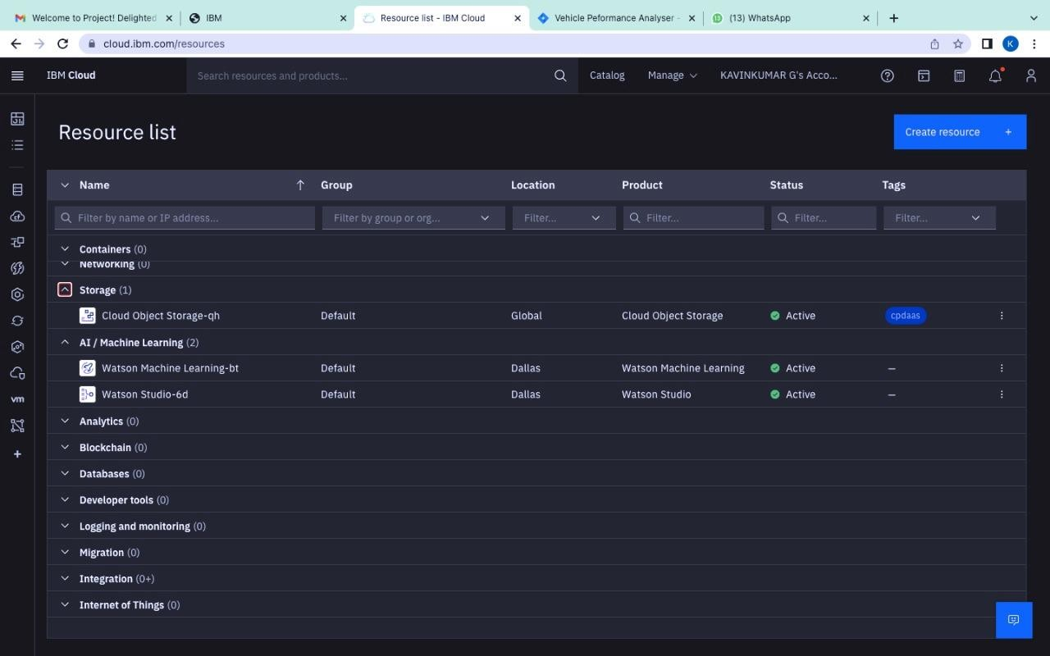

1. IBM Watson Studio and Watson Machine Learning has been Created:

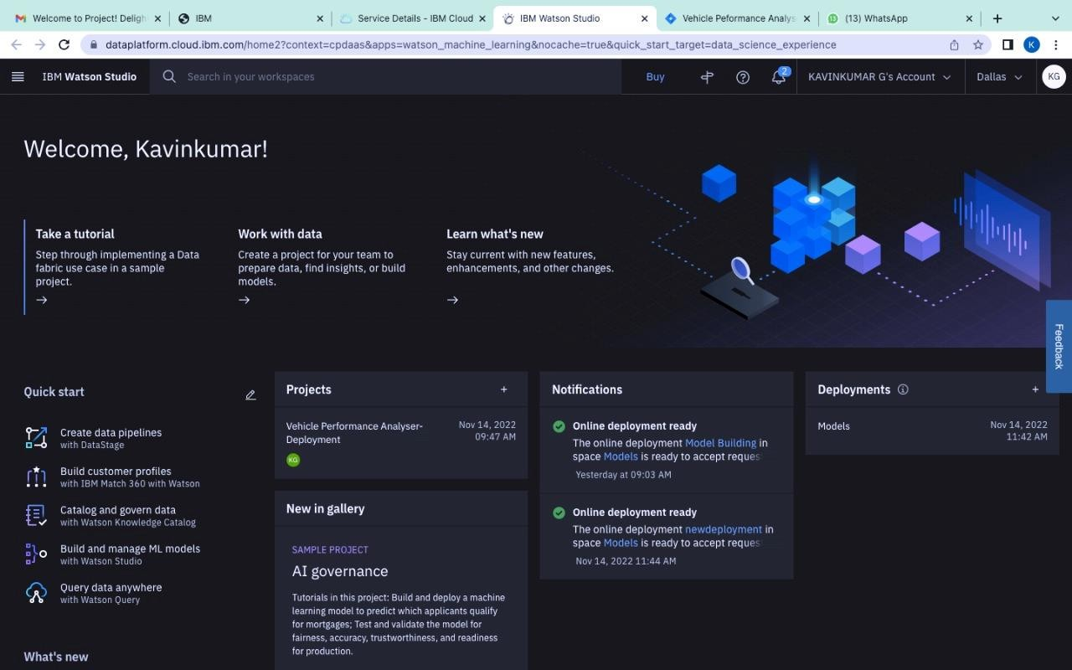

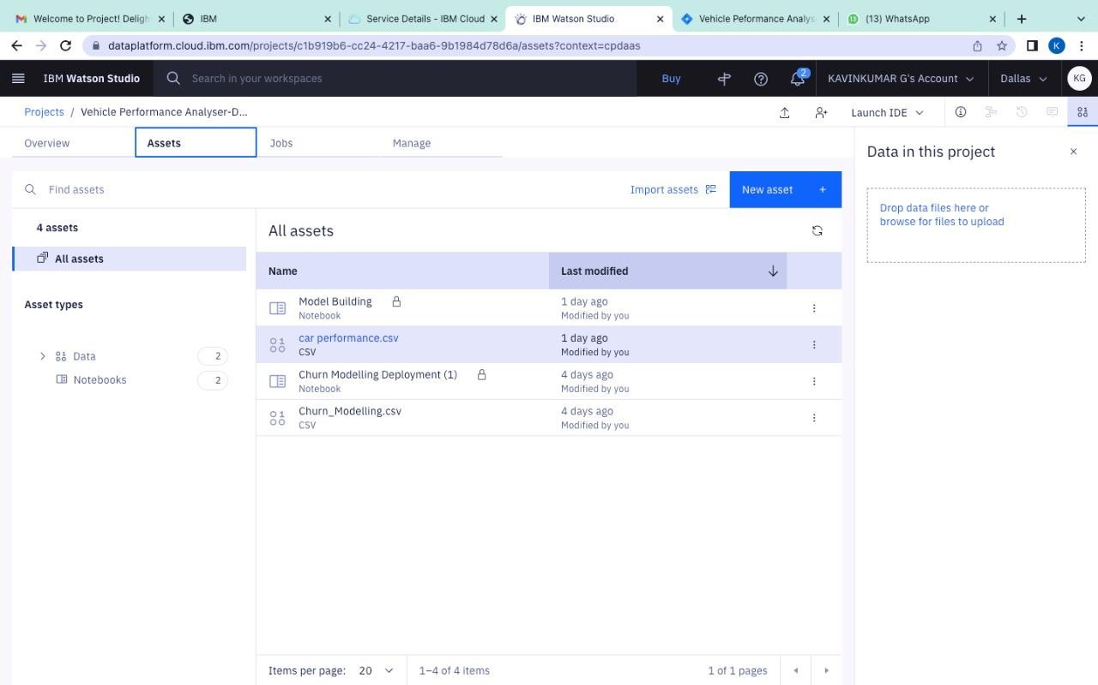

1. Cloud Object Storage list:

